**karakteristik Hasil Perikanan**

[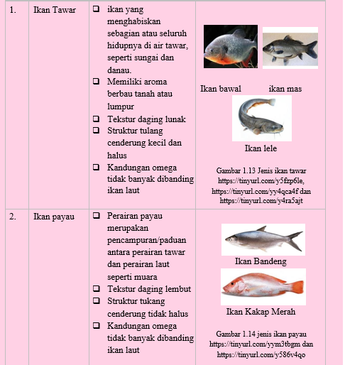](https://1.bp.blogspot.com/-0yA7umLVYT8/YP35otetpUI/AAAAAAAABJo/N8gXfYgb5BMfeml3iuFN8jCGjz1yFae1wCLcBGAsYHQ/s514/ciri%2Bikan-1.PNG)

[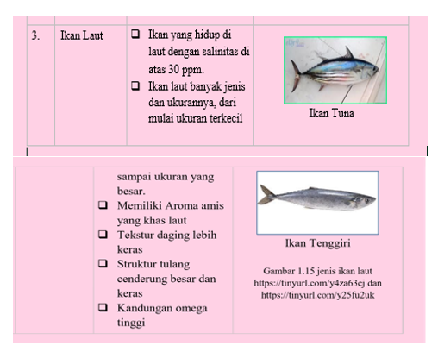](https://1.bp.blogspot.com/-Qyr7RO1tUXo/YP39P8krSlI/AAAAAAAABJ4/sF0c3Ot-SAQ98wKtCy9ZYcJmX9aglEgKwCLcBGAsYHQ/s508/ciri%2Bikan%2B2-3.PNG)

[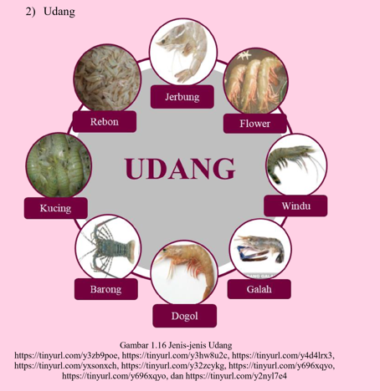](https://1.bp.blogspot.com/-r6jTfxbz6cE/YP3905DTl_I/AAAAAAAABKA/5as9SDU7HjMVVlrO3i6qI3JAvoU9EkhlgCLcBGAsYHQ/s468/ciri%2Budang.PNG)

[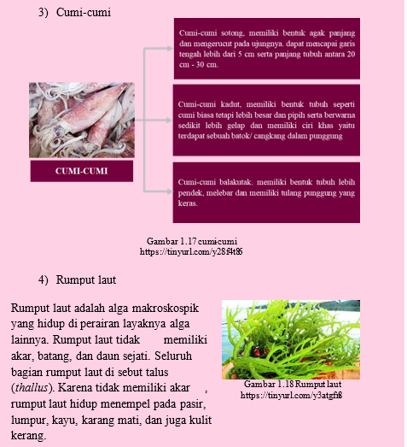](https://1.bp.blogspot.com/-SvM3FN9LEfI/YP3-IiOtPHI/AAAAAAAABKI/Na7lLPdA7O0sxHDsfwWAOliGeGyAEuW-wCLcBGAsYHQ/s523/ciri%2Bcumi%2B%2526%2Brumput%2Blaut.PNG)